
Bangladesh University of Engineering and Technology

CSE 306
Computer Architecture Sessional
Assignment-3: 4-bit MIPS Design, Simulation, and Implementation
Section - B1
Group - 03

Members of the Group:
1. 2005071 – Sagor Chanda
2. 2005069 – Souvik Mandol
3. 2005076 – S. M. Kausar Parvej
4. 2005068 – Md. Sumon Hossain
5. 1705083 – Hozifa Rahman Hamim

- Introduction
MIPS (Microprocessor without Interlocked Pipeline Stages) is a RISC (Reduced Instruction Set Computer) architecture widely used in embedded systems, networking devices, and other applications requiring efficient processing power. Its fixed instruction set ensures regularity and simplicity in instruction execution.
Here is an example of add instruction:

Operation | Example | Instruction | Corresponding Action
Addition | x = a + b | add $t2, $t1, $t3 | $t2 = $t1 + $t3

In MIPS, instructions are typically executed in a pipeline fashion, where each stage of the pipeline handles a different aspect of instruction execution, such as instruction fetch, decode, execute, memory access, and write back. This pipelining allows for efficient processing of multiple instructions simultaneously.

The MIPS datapath consists of various components, including registers, ALUs (Arithmetic Logic Units), MUXs (Multiplexers), memories, and control elements, which work together to process instructions efficiently. The datapath is responsible for executing instructions by performing operations such as arithmetic and logic operations, memory accesses, and control transfers.

- Instruction Set
In this assignment we are designing a 4-bit MIPS which is consists of:
- 8-bits Address bus
- 4-bits Data bus
- 4-bit ALU
- Temporary registers are: $zero, $t0, $t1, $t2, $t3, $t4

Instruction set for this MIPS is given below:
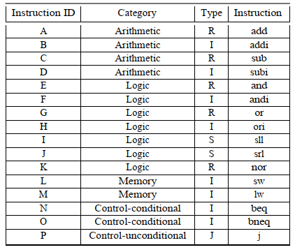
Table 1: Instruction Set Description

Our MIPS Instructions will be 16-bits long with the following four formats

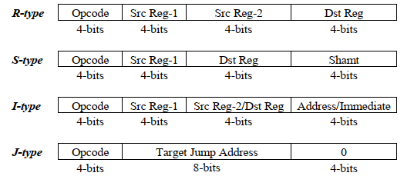
Table 2: Instruction Format

Opcodes of the instructions are of 4 bits, so between 0 and 15. We’re given the Instruction assignment POJMBNDECAGIHKLF. So, our instruction set would be something like this:

Opcode | Instruction ID | Category | Type | Instruction
0000 | P | Control-unconditional | J | j
0001 | O | Control-conditional | I | bneq
0010 | J | Logic | S | srl
0011 | M | Memory | I | lw
0100 | B | Arithmetic | I | addi
0101 | N | Control-conditional | I | beq
0110 | D | Arithmetic | I | subi
0111 | E | Logic | R | and
1000 | C | Arithmetic | R | sub
1001 | A | Arithmetic | R | add
1010 | G | Logic | R | or
1011 | I | Logic | S | sll
1100 | H | Logic | I | ori
1101 | K | Logic | R | nor
1110 | L | Memory | I | sw
1111 | F | Logic | I | andi

Table 3: Instruction for section B1-Group 3

- Complete Block diagram of a 4-bit MIPS processor

- Block diagrams of the main components

- Approach to implement the push and pop instructions

- ICs used with their count

IC Number | IC Name | Count
ATmega 32 | ATmega | 6
IC 74157 | Mux | 6
IC 7483 | Adder | 2

- Discussion
- For implementing the circuit in software level , we used 7400-library integrated circuits. In hardware level, necessary coding has been done at ATMEGA level.
- In hardware level, we showed the value of each register by setting ShowReg in the register file On. From the ALU, we demonstrated output in each step of operation.
- The value of PC was also shown for each clock cycle. The value of each data memory was also visible at software level.
- All of our ATmega were tested before integrating it to our final circuit.
- Wires with different sizes were used to make the whole circuit organized and easily understandable for the user.
- The outputs were checked multiple times for a large number of input test cases to ensure that our circuit satisfies the expected output values from the given input file.
- In order to optimize the number of IC , we performed PC+1 using the Cin value of the adder. Similarly instead of generating a circuit to create a selector bit bsel ( whether to branch or not ) , we calculated the value in ATmega designated for ALU operation .
- Clock pulse was provided using a Push Button Switch.

- Contribution

ID | Contribution
2005076 | Software implementation, Hardware implementation, Debugging, Report writing
2005071 | Hardware implementation, Report writing, Debugging
2005069 | Hardware implementation, Report writing, Debugging
2005068 | Hardware implementation, Report writing, Diagram drawing
1705083 | Hardware implementation, Report writing, Debugging

